Identification of Critical Activities and Associated Risks in Microtunnelling Construction Projects
Volume X Issue X (20XX) Page. X - XX

 |  | ISSN: 3110-1119
 |  | Journal of Project Management Research
 |  | Journal Homepage: https://journalpmresearch.com/jpmr
Title should be written in non-capital letters/sentence case using Avenir Next LT Pro Next LT Pro font, size 14, bold (maximum 15 words) |  |  | 
Author ¹⁾, Author ²⁾, Author ³⁾ etc
^{1), 2)} Name of Affiliation
³⁾ Name of Affiliation
Corresponding author, e-mail: author@email.com [leave this section empty, enter author detail in separate document]
ABSTRACT |  |  | KEYWORDS
Background, Purpose, Method, Findings, Conclusion [Avenir Next LT Pro, 8, normal], single-spaced, maximum 300 words |  |  | Keyword 1, keyword 2, keyword 3 [Avenir Next LT Pro, 8, normal], single-spaced, maximum 300 words
How to cite: (by publisher)
General guideline:
- The manuscript must be written in English and in Ms. Word format (doc/docx).
- Page size is A4 with margin 2-2-2-2.
- Font used is Avenir Next LT Pro, size varies between:
  - 14 for title
  - 12 for headings and author name
  - 11 for subheading and body text
  - 10 for texts inside tables, figure & table caption, and sources
  - 8 for abstract, keywords, and article info
- Paragraph is single-spaced and set to Justify.
- The article manuscript generally includes the following sections:
1. Introduction
2. Literature Review
3. Methodology
4. Results and Discussion
5. Conclusion
6. Acknowledgement (optional section)
7. References
- Do not change/edit the Styles.
- Do not change header, footer and page number.
- The manuscript must have a minimum word count of 7,000.

INTRODUCTION [Avenir Next LT Pro, 12, Heading 1], single-spaced.
The Introduction should address: (1) background, (2) a brief literature review of related research, (3) reasons for conducting this research, and (4) questions about the objectives or research question. The sophistication, gap analysis, and novelty should be evident here. [Avenir Next LT Pro, 11, normal], single-spaced.

LITERATURE REVIEW [Avenir Next LT Pro, 12, Heading 1], single-spaced.
This section critically examines existing research to contextualize the study, summarize key theories, and identify gaps and trends. It reviews methodologies and relevant hypotheses from prior studies, highlighting how they inform and justify the current research. This section demonstrates how the study builds on or challenges existing knowledge, providing a focused and organized overview of the literature directly related to the research questions and hypotheses. [Avenir Next LT Pro, 11, normal], single-spaced.

Key Theory [Avenir Next LT Pro, 11, Heading 2], single-spaced.

Theory 1 [Avenir Next LT Pro, 11, Heading 3], single-spaced.

Theory 2 [Avenir Next LT Pro, 11, Heading 3], single-spaced.

Hypotheses [Avenir Next LT Pro, 11, Heading 2], single-spaced.

METHODOLOGY [Avenir Next LT Pro, 12, Heading 1], single-spaced.
This section outlines the research design and methods, including data collection techniques, sampling procedures, and tools used. It explains the rationale for these choices, how they align with the research objectives, and procedures for ensuring reliability and validity. Additionally, it describes the data analysis process, providing a clear account of how the research was conducted to enable replication and understanding of the findings. [Avenir Next LT Pro, 11, normal], single-spaced.

RESULTS & DISCUSSION [Avenir Next LT Pro, 12, Heading 1], single-spaced.
This section includes the results of data analysis, hypothesis testing, answers to research questions, findings, and interpretation of the findings. The use of tables, figures, and other materials should be strictly supportive and substantial, such as tables of statistical test results, figures of model test results, etc. The discussion of results should be argumentative, addressing the relevance between results, theory, previous research, and empirical facts found, as well as demonstrating the novelty of the findings. [Avenir Next LT Pro, 11, normal], single-spaced.
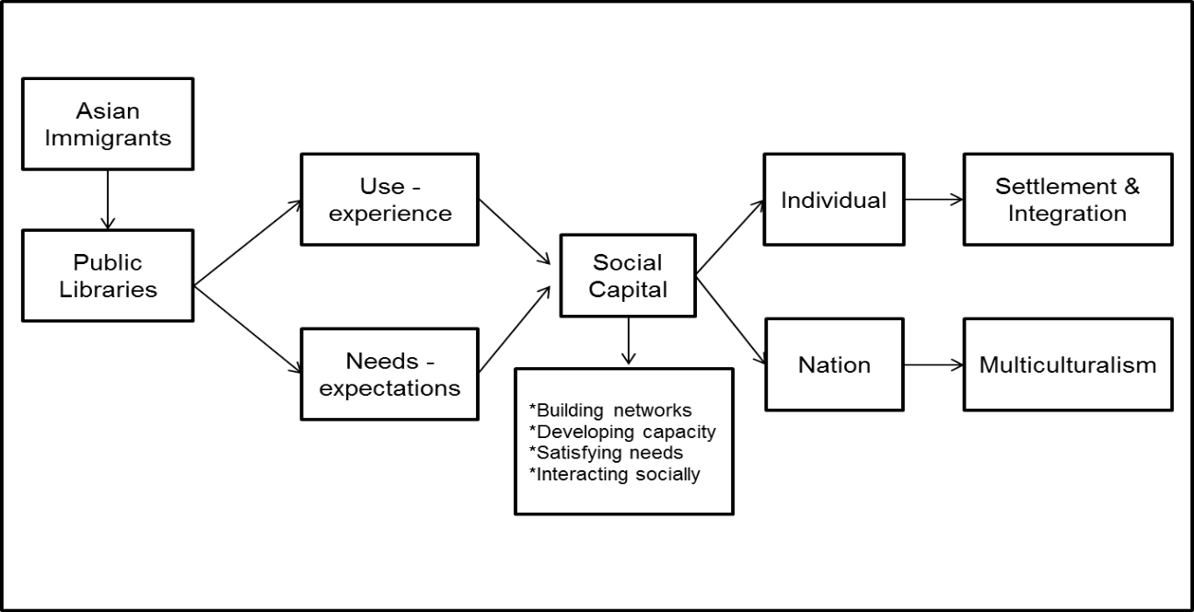
Figure 1. Model of Community Library Use by Immigrants (10 pt)
Table 1. Reasons for visiting the library (10 pt)
No | Reasons for visiting the library (10 pt) | Frequency  (n=139) | %
1 | Looking for sources of information | 88 | 63%
2 | Studying | 59 | 42%
3 | Meeting friends | 55 | 40%
4 | Returning collections | 51 | 37%
5 | Accessing Internet | 48 | 34%
Source: Primary data processed, 2022 (10 pt)

CONCLUSION [Avenir Next LT Pro, 12, Heading 1], single-spaced.
Conclusion may not be repetitions of ideas presented previously. It should provide implications of research and wider conception of ideas/understanding resulting from research. Include these following sub-headings: [Avenir Next LT Pro, 11, normal], single-spaced.

Practical Implication [Avenir Next LT Pro, 11, Heading 2], single-spaced.

Limitations and Future Research [Avenir Next LT Pro, 11, Heading 2], single-spaced.

ACKNOWLEDGEMENT* [Avenir Next LT Pro, 12, Heading 1], single-spaced.
In the acknowledgment section, briefly recognize individuals who provided significant help but are not authors, such as assistance with data collection or analysis. Acknowledge institutional and financial support by naming relevant organizations, grants, or funding bodies. Ensure that those mentioned have consented to be acknowledged. Avoid personal dedications or statements that could imply bias. [Avenir Next LT Pro, 11, normal], single-spaced.
*This is an optional section

REFERENCES [Avenir Next LT Pro, 12, Heading 1], single-spaced.
All in-text citations must be registered in the References. A reference management application/software must be used, such as Mendeley, EndNote, Zotero, or others, and refer to APA 7th Edition (American Psychological Association).
The following are some examples of the 7th edition of the APA reference style:
Book chapters:
Aarnitaival, S. (2010). Becoming a citizen-becoming information-literate? Immigrants’ experiences of information literacy learning situations in Finland-Chapter 14. In A. Lloyd & S. Talja (Eds.), Practicing information literacy. Bringing theories of learning, practice and information literacy together (pp. 301-329). Center for Information Studies, Charles Sturt University.
Strauss, A., & Corbin, J. (1994). Grounded theory methodology. In N. K. Denzin & Y. S. Lincoln (Eds.), Handbook of qualitative research (pp. 273-285). Sage.
Yura, P. (2020). ‘Good or bad’: How people think of me is not important. In B. Rudy & H. Dion (Eds.), Mental health policy: Bringing theories of learning and information literacy in practice (pp. 368-389). University of Life Press.
Books:
Aaker, D. A., Day, G. S., & Kumar, V. (2013). Marketing research (11th ed.). Wiley.
Journal articles with no doi:
Khoir, S., Du, J. T., Davison, R. M., & Koronios, A. (2017). Contributing to social capital: An investigation of Asian immigrants' use of public library services. Library & Information Science Research, 39(1), 34-45.
Loudon, K., Buchanan, S., & Ruthven, I. (2016). The everyday life information seeking behaviors of first-time mothers. Journal of Documentation, 72(1), 24-46.
Yu, L. (2011). The divided views of the information and digital divides: A call for integrative theories of information inequality. Journal of Information Science, 37(6), 660-679.
Journal articles with doi:
Khoir, S., Du, J. T., & Koronios, A. (2015). Linking everyday information behavior and Asian immigrant settlement processes: Towards a conceptual framework. Australian Academic & Research Libraries, 46(2), 86-100. https://doi.org/10.1080/00048623.2015.1024303
Conference proceedings:
Khoir, S., Du, J. T., & Koronios, A. (2014). Study of Asian immigrants’ information behaviour in South Australia: Preliminary results. Proceeding iConference, March 4-7 2014, Berlin, Germany, pp. 682-689. https://www.ideals.illinois.edu/handle/2142/47274
Internet Documents and Government Publication:
Mercer, P. (2012). Immigrants change Australia's cultural identity. Voice of America News. http://www.voanews.com/content/immigrants-change-australias-cutural-identity/1246298.html
State Library of South Australia. (n.d). Strategic plan 2014-2017. http://www.slsa.sa.gov.au/webdata/resources/files/State_Library_of_SA_Strategic_Plan_2014-2017_-_Low_Resolution.pdf
For more than 1 author – in the in-text citation, we only write the name of the first author’s last name, immediately followed by et al.
Example:
(Garrett et al., 2020)
Place (city) of publication is no longer included in the reference.
Example:
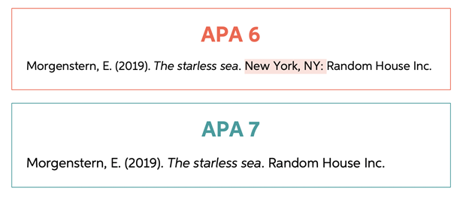
DOI is written in complete format as follows: https://doi.org/xxxxx
Example:
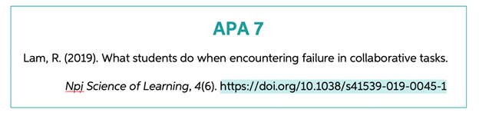
No need to include the words "Accessed from" or "Retrieved from" before the URL.
Example:
Betts, J. (2020, July 18). APA format and citations. Bibliography.com: www.bibliography.com/apa/apa-format-and-citations/

